SITE SURVEY REPORT

Table of Contents
Section I: GENERAL INFORMATION 3
Section II: SITE A INFORMATION 4
Site A: Photos 6
Photos: Building/Tower/Infrastructure 6
Photos: Pole and Mounting Point 7
Photos: Other devices installed on pole/site 8
Photos: Miscellaneous 8
SITE A: LINE OF SIGHT CHECK (to SITE B) 9
No zoom with camera as placed in above diagram 10
Maximum zoom with camera as placed in above diagram. 10
Video of line of sight from Site A towards Site B 10
SITE A: POWER 11
Power source(s) and installation 11
Photo(s) 11
SITE A: NETWORK 12
Network equipment and configuration 12
Photo(s) 12
Section III: Site B INFORMATION 13
Site B: Photos 15
Photos: Building/Tower/Infrastructure 15
Photos: Pole and Mounting Point 16
Photos: Other devices installed on pole/site 17
Photos: Miscellaneous 17
SITE B: LINE OF SIGHT CHECK (to SITE A) 18
No zoom with camera as placed in above diagram 19
Maximum zoom with camera as placed in above diagram. 19
Video of line of sight from Site B towards Site A 19
SITE B: POWER 20
Power source(s) and installation 20
Photo(s) 20
SITE B: NETWORK 21
Network equipment and configuration 21
Photo(s) 22
Section IV: APPENDIX 23
See the following documents for additional information 23
Site Selection Best Practice Guide 23
Using Power over Ethernet (PoE) and Management Cable 23
Using Management Cable without PoE 24

Section I: GENERAL INFORMATION

Item | Details
Product to be installed | Centauri 1/Centauri 10
Link Planning Tool Line of Sight Verified  (link planning tool) | Pass/Fail
Distance between Site A and SIte B
On Site Line of Sight Verified | Pass/Fail
Survey Date(s)
On Site Survey Performed by (SI Team Leader) | Name:  Company:  Email:  Mobile:  Sign:
Site Survey Approved by (Operator in Charge) | Name:  Company:  Email:  Mobile:  Sign:
Site Survey Verified by (Transcelestial) | Name:  Email:  Mobile:  Sign:

Section II: SITE A INFORMATION

Item | Details
Site Address
GPS Coordinates
Building/Tower Height (above ground level) | Height:
Site Type | - FREESTANDING MONOPOLE  - MONOPOLE ON BUILDING  - FREESTANDING LATTICE TOWER  - LATTICE TOWER ON BUILDING  - COW  - OTHERS (Please specify)
Mounting Pole Shape, Size and Height | - Cylindrical  - L-Shaped  - Square Shaped  Diameter/Width:  Height:
Angle to the ground  (Ensure pole is vertical to ground, acceptable range: 87-93 degrees)  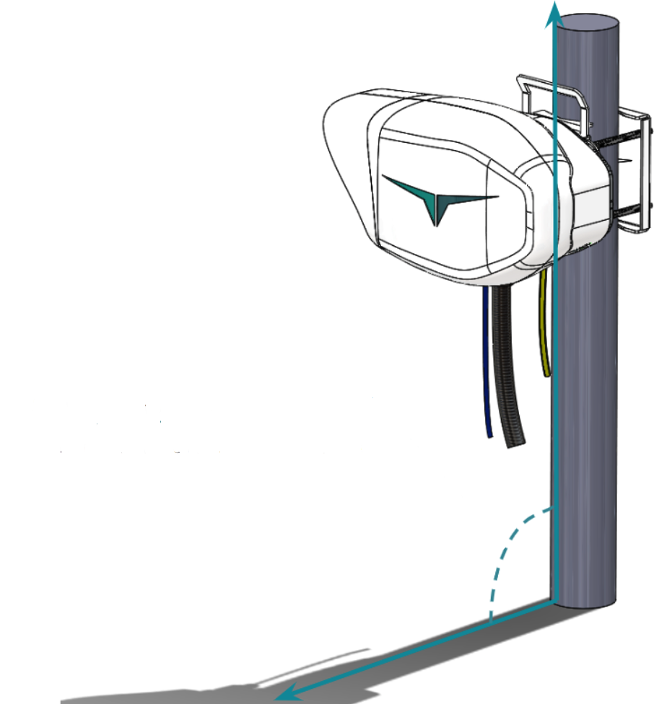 | (Note: Device can compensate for maximum roll angle of 3 degrees)
Pole Installation Type and Point of Installation | - Pole mounted on concrete plinth (Overall dimensions 800mm x 800mm x 100mm)  - Pole mounted on wall  - Pole mounted on roof ledge
Installation Point:  Distance from nearest anchor or stabilization point: | Distance:
Are there any potential sources of vibration (construction, machining shop, etc.) within 2m (7 ft) of the pole? | Yes/No
Mount Recommendation (round pole, 3 to 4 in/7.6 to 10.2 cm))  Max diameter supported is 4 in/10.2 cm | Mount diameter:

Site A: Photos

Photos: Building/Tower/Infrastructure

Photos: Pole and Mounting Point
Please indicate all possible options on photo

Photos: Other devices installed on pole/site

Photos: Miscellaneous
Please provide additional photos of site and surroundings as needed.

SITE A: LINE OF SIGHT CHECK (to SITE B)

Item | Details
Are there any obstructions to the line of sight? | Yes / No
Are there any large plants/trees that might grow to become an obstacle, or which may sway during heavy winds, becoming an obstacle? | Yes / No
Are there any HVAC (Heat, Vents and Air Conditioner exhausts) within 2 m/6.5 ft of the line of sight? | Yes / No
Any source of heat/smoke (air vents that collect kitchen exhaust, transformers) within 2m/6.5 ft of the line of sight? | Yes / No

Photos of the line of sight (follow diagram/instructions below in taking the photos)
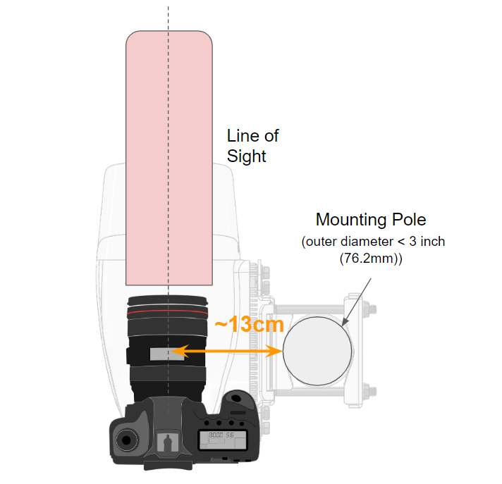

No zoom with camera as placed in above diagram
Please indicate location of remote end of link (Site B)

Maximum zoom with camera as placed in above diagram.
Please indicate location of remote end of link (Site B)

Video of line of sight from Site A towards Site B
Take a video of the line of sight (Attach link to file if using shared storage service like Google Drive, Dropbox, MS OneDrive, etc)

SITE A: POWER

Power source(s) and installation
Item | Details
Electrical tapping point | - Electrical box on pole  - Electrical room
Power Availability (Voltage and breaker current) | - AC: Voltage/Current  - DC: Voltage/Current
Distance from tapping point to CENTAURI
Grounding available on Pole | Yes / No
If DC power supply, please specify cable specs | DC cable length:  DC cable diameter:
Power Recommendation | PoE (max 50m) / 48V DC

Photo(s)

SITE A: NETWORK

Network equipment and configuration
Item | Details
Network element for optical data | Switch ID
Manufacturer and Model
Interface port number
Interface Type | - SFP  - SFP+  - XFP  - Other (please specify)
Interface Fiber mode | Single mode / Multimode
Interface Fiber connector | - LC  - SC  - Other (please specify)
Interface Wavelength
Network element for 100BASE-T MANAGEMENT  (ONLY IF OUT-OF-BAND) | Switch ID
Manufacturer and Model
Interface Port Number
Management Cable | - Direct CAT6A U-STP (up to 100m)  - CAT6A U-STP with range extender (up to 200m)

Photo(s)

Section III: Site B INFORMATION

Item | Details
Site Address
GPS Coordinates
Building/Tower Height (above ground level) | Height:
Site Type | - FREESTANDING MONOPOLE  - MONOPOLE ON BUILDING  - FREESTANDING LATTICE TOWER  - LATTICE TOWER ON BUILDING  - COW  - OTHERS (Please specify)
Mounting Pole Shape, Size and Height | - Cylindrical  - L-Shaped  - Square Shaped  Diameter/Width:  Height:
Angle to the ground  (Ensure pole is vertical to ground, acceptable range: 87-93 degrees) | (Note: Device can compensate for maximum roll angle of 3 degrees)
Pole Installation Type and Point of Installation | - Pole mounted on concrete plinth (Overall dimensions 800mm x 800mm x 100mm)  - Pole mounted on wall  - Pole mounted on roof ledge
Installation Point:  Distance from nearest anchor or stabilization point: | Distance:
Are there any potential sources of vibration (construction, machining shop, etc.) within 2m (7 ft) of the pole? | Yes/No
Mount Recommendation (round pole, 3 to 4 in/7.6 to 10.2 cm))  Max diameter supported is 4 in/10.2 cm | Mount diameter:

Site B: Photos

Photos: Building/Tower/Infrastructure

Photos: Pole and Mounting Point
Please indicate all possible options on photo

Photos: Other devices installed on pole/site

Photos: Miscellaneous
Please provide additional photos of site and surroundings as needed.

SITE B: LINE OF SIGHT CHECK (to SITE A)

Item | Details
Are there any obstructions to the line of sight? | Yes / No
Are there any large plants/trees that might grow to become an obstacle, or which may sway during heavy winds, becoming an obstacle? | Yes / No
Are there any HVAC (Heat, Vents and Air Conditioner exhausts) within 2 m/6.5 ft of the line of sight? | Yes / No
Any source of heat/smoke (air vents that collect kitchen exhaust, transformers) within 2m/6.5 ft of the line of sight? | Yes / No

Photos of the line of sight (follow diagram/instructions below in taking the photos)

No zoom with camera as placed in above diagram
Please indicate location of remote end of link (Site B)

Maximum zoom with camera as placed in above diagram.
Please indicate location of remote end of link (Site A)

Video of line of sight from Site B towards Site A
Take a video of the line of sight (Attach link to file if using shared storage service like Google Drive, Dropbox, MS OneDrive, etc)

SITE B: POWER

Power source(s) and installation
Item | Details
Electrical tapping point | - Electrical box on pole  - Electrical room
Power Availability (Voltage and breaker current) | - AC: Voltage/Current  - DC: Voltage/Current
Distance from tapping point to CENTAURI
Grounding available on Pole | Yes / No
If DC power supply, please specify cable specs | DC cable length:  DC cable diameter:
Power Recommendation | PoE (max 50m) / 48V DC

Photo(s)

SITE B: NETWORK

Network equipment and configuration
Item | Details
Network element for optical data | Switch ID
Manufacturer and Model
Interface port number
Interface Type | - SFP  - SFP+  - XFP  - Other (please specify)
Interface Fiber mode | Single mode / Multimode
Interface Fiber connector | - LC  - SC  - Other (please specify)
Interface Wavelength
Network element for 100BASE-T MANAGEMENT  (ONLY IF OUT-OF-BAND) | Switch ID
Manufacturer and Model
Interface Port Number
Management Cable | - Direct CAT6A U-STP (up to 100m)  - CAT6A U-STP with range extender (up to 200m)

Photo(s)

Section IV: APPENDIX

See the following documents for additional information on guidance for selecting appropriate sites and for detailed instructions for installing CENTAURI.

Site Selection Best Practice Guide
- CENTAURI Product Manual

